Day 6 - Deployment Preparation and Staging Environment Setup

Deployment Details

• Hosting Platform: Vercel

• Repository Link:

<https://github.com/S-M-Usman/GIAIC_Marketplace_Builder_Hackathon_2025/>

• Staging URL:

<https://giaic-marketplace-builder-hackathon-2025.vercel.app/>

Environment Setup Process

1. Hosting Platform Setup:

o Selected hosting platform: Vercel.

o Connected GitHub repository to Vercel.

o Configured build settings and added environment variables for secure deployment.

1. Environment Variables:

o Created a .env file with the following variables:

▪ NEXT_PUBLIC_SANITY_PROJECT_ID: Sanity project identifier.

▪ NEXT_PUBLIC_SANITY_DATASET: Dataset name for production.

▪ API_KEY: API key for third-party services.

o Uploaded environment variables securely to Vercel.

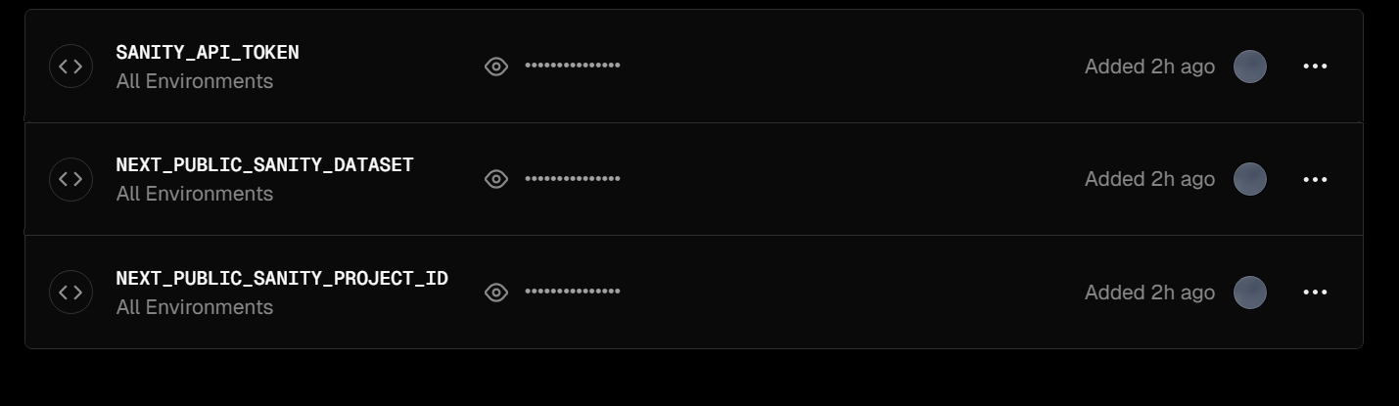

1. Staging Deployment:

o Deployed the application to the staging environment.

o Verified the build process completed successfully.

o Validated that the site loaded correctly

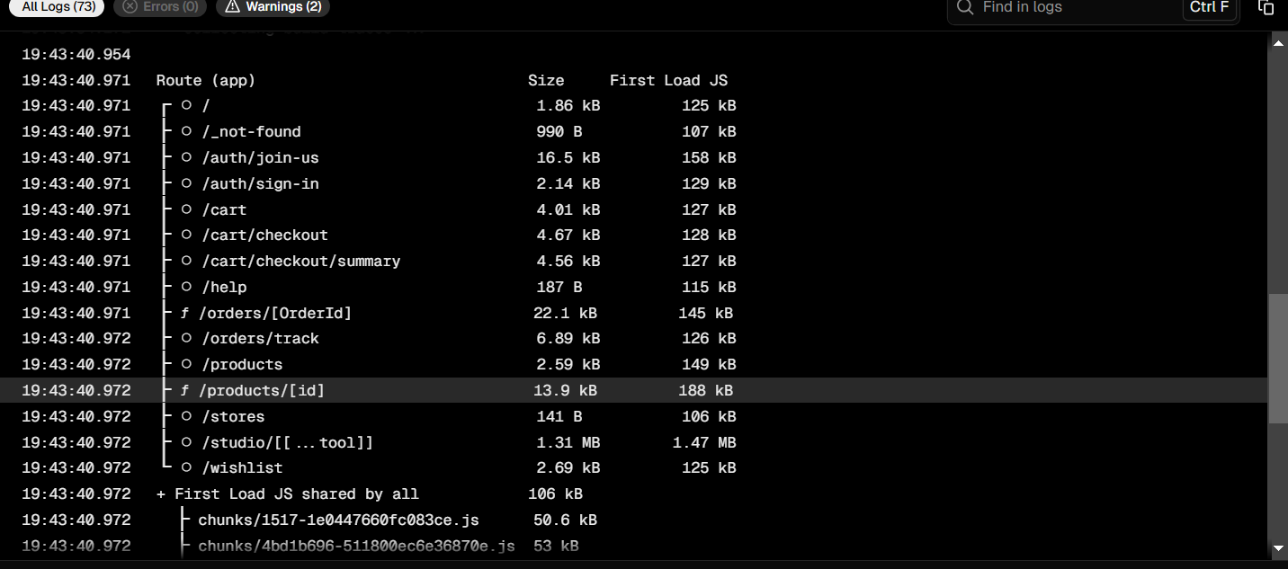

Performance Testing Report

1. Desktop Performance:

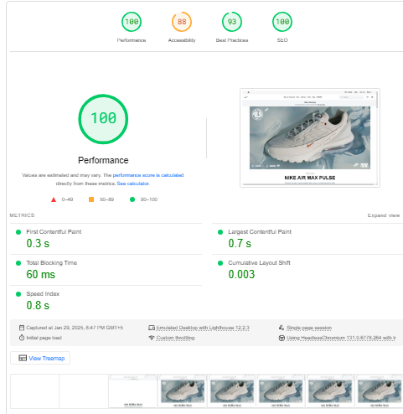

1. Mobile Phone Performance:

